# Durable Furnitures

Noir

## New York Contemporary TV Stand #1

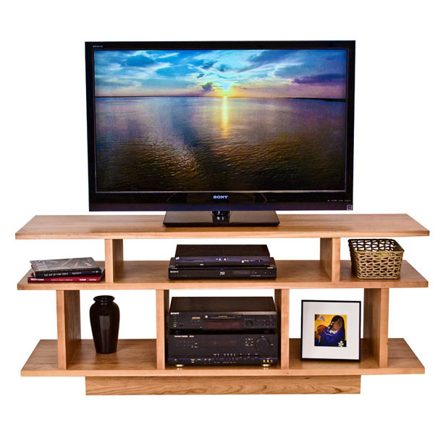

Our New York Contemporary TV Stand is perfect for housing flat screen TV's and all your other media equipment. It has a simple, modern design that will blend in perfectly in any contemporary living room.